# Setup

## Starting elasticsearch

In elasticsearch folder run

bin/ elasticsearch.bat

## Starting kibana

In kibana folder run

bin/kibana.bat

elasticsearch will running on port 9200

kibana will be running on port 5601

## Reset elasticsearch password

Reset elasticsearch password if not shown on elasticsearch console

in another cmd run

bin\elasticsearch-reset-password.bat -u elastic

following password got generated after running above command

OEiIkLxGz6CIvH+5Xlf7

## Authorizing kibana to connect to elasticsearch

### Works only if x-pack

is being used. Token generation to link elasticsearch with kibana

bin\elasticsearch-create-enrollment-token.bat -s kibana

expires in 30 mins. must register with kibana in 30 mins

### Generating an elasticsearch token

for usage in Kibana

c:\elastic\elasticsearch-8.4.1\bin>elasticsearch-service-tokens create elastic/kibana kibana-token

warning: ignoring JAVA_HOME=C:\Program Files\Java\jdk-11.0.13; using bundled JDK

SERVICE_TOKEN elastic/kibana/kibana-token = AAEAAWVsYXN0aWMva2liYW5hL2tpYmFuYS10b2tlbjpfLTJWdDJaVlItNnU1eDRsbGhOSHFn

### Setting the elasticsearch token in Kibana

copy the token to kibana folder config\kibana.yaml

property name is elasticsearch.serviceAccountToken

### Launching Kibana on default 5601 port

In kibana folder

bin/kibana.bat (if not already running or changes done)

launch http://localhost:5601/ from browser

login using superuser elastic credentials

username: elastic

password generated for elasticsearch in first step: OEiIkLxGz6CIvH+5Xlf7

# Kibana - Dev Tools menu

Kibana - Dev Tools menu to run Elasticsearch REST APIs

## Health of the cluster API

GET /_cluster/health

**_cluster** is the name of the API - starts with underscore as a convenntion for an API name

**health** is the name of the command

https://www.elastic.co/guide/en/elasticsearch/reference/current/cluster-nodes-info.html

If the status of cluster is not green, we will have to find out more details. Status yellow - eg: when we do not have replica of a shard. This is risky, hence yellow. _cat/shards?v can tell or give a clue that a replica shard is UNASSIGNED to any node.

## CAT - (Compact and Aligned Text) API

CAT API provides API to find more details using the command nodes

GET /_cat/nodes?v

v - header included

https://www.elastic.co/guide/en/elasticsearch/reference/current/cat-nodes.html

Indices with documents are like Rows in a table

### View indices

GET /_cat/indices?v

### View hidden/kibana internal indices

GET /_cat/indices?v&expand_wildcards=all

## Generting an api key to connect from other softwares

POST /_security/api_key

{

"name": "test"

}

https://www.elastic.co/guide/en/elasticsearch/reference/current/security-api-create-api-key.html

### CURL Using the API key

Instead of Kibana to run REST API requests to Elasticsearch, we are using CURL to interact from outside of Kibana

C:\Users\j1012496>curl -X GET http://localhost:9200 -H "Authorization: ApiKey cUxxbEo0TUJnSnNqUjZ1bkliXzU6UUd4RHdMdzJUaENZTThPYk02QzQ4dw=="

Response:

{

"name" : "IN2-1012496LTT",

"cluster_name" : "elasticsearch",

"cluster_uuid" : "YGHDocw0Ro2pXp87KzlAcQ",

"version" : {

"number" : "8.4.1",

"build_flavor" : "default",

"build_type" : "zip",

"build_hash" : "2bd229c8e56650b42e40992322a76e7914258f0c",

"build_date" : "2022-08-26T12:11:43.232597118Z",

"build_snapshot" : false,

"lucene_version" : "9.3.0",

"minimum_wire_compatibility_version" : "7.17.0",

"minimum_index_compatibility_version" : "7.0.0"

},

"tagline" : "You Know, for Search"

}

### CURL using API key to search

C:\Users\j1012496>curl -H "Authorization: ApiKey cUxxbEo0TUJnSnNqUjZ1bkliXzU6UUd4RHdMdzJUaENZTThPYk02QzQ4dw==" -H "Content-Type: application/json" -X GET http://localhost:9200/products/_search -d "{ \"query\": { \"match_all\": {} } }"

# Sharding

Sharding splits the index into smaller pieces called shards. Scales to store more data in an index and improves performance as it gives scope for concurrent searches across shards.

## Split API

To increase the shards for an index from default value 1

## Shrink API

To reduce the number of shards for an index

## Snapshots

Snapshots help in data backup towards EOD generally. Helps if data is screwed up.

## Shard Replicas

Replicas help in duplication of data in live. A replica shard is never stored on the same node as its primary shard. Primary shard and its replica shards together is called as replication group. One replica shard if the application is not mission critical. Two replicas on 2 different nodes if the application is mission critical. Default number of replicas per shard is 1. For a new index, by default if we do not mention the number of shards, just 1 primary shard will be created. Along with primary shard a replica shard will be created by default. So 2 shards by default - one p and one r.

If we have another node with 2 Replica Shards of same Primary shard, it is possible Elasticsearch may handle 3 concurrent requests for the same data range. This is possible because both replica shards and one primary shard can be queried with the help of multiple cores on the machine.

So replication helps in Increasing Availability and Increasing Throughput if the CPU resources are available for usage.

## CAT API to know current shards

To know how many shards we have for every index and which of those are replicas, size of shard, no. of documents in shards, IP address of shard node etc

GET /_cat/shards?v

To create a new index by all defaults

PUT /pages

GET /_cat/shards?v

## Adding a new node to elastic cluster

If a new node on the local machine is to be added, start from elasticsearch.zip file fresh for second node.

change the node name in elasticsearch/config/elasticsearch.yaml

### Create enrollment token

From first node, generate an enrollment token for the second node to join the cluster.

bin/elasticsearch-create-enrollment-token --scope node for a new node

bin/elasticsearch-create-enrollment-token --scope kibana for a new kibana

Now start the new elastic search providing the enrollment token generated

second-node-elastic-folder> bin/elasticsearch --enrollment-token <token>

### Health check of the cluster

Now check /_cluster/health and we see status is green and number of nodes is 2

System indices (starting with a DOT .) are configured as

Configuration: index.auto_expand_replicas: 0-1

So they too get replicated though they did not have UNASSIGNED replica shards before starting second node

## Node roles

master-eligible

This role does not mean it is a master. Master is elected by a voting process among nodes.

If a master node is very busy serving requests all the time, it may not be able to handle the system activities like creating/deleting indices, handling replica communication etc. efficiently. In such case it is advisable to have a dedicated master node to perform only system activities.

Configuration: node.master: true

data

Maintains data, queryinh and modifying of data can be performed.

Configuration: node.data: true

This is generally used if we decide to have dedicated master node and have data nodes separately.

ingest

A node to run ingest pipelines. We can think of this as a simple logstash pipeline within elasticsearch itself reading every line and converting into a document. Changing IP address into lat/log etc. before adding the document.

Configuration: node.ingest: true

If set to false, the node will not store any shards.

Machine Learning

Configuration

node.ml: true

xpack.ml.enabled: true

Coordination

Distibution of queries among nodes and aggregation of results.

All types of nodes do this kind of activity. But if we want a node to do only coordination, it can be achieved by only turning off other roles on that node.

Configuration

node.master: false

node: data: false

node.ingest: false

node.ml: false

xpack.ml.enabled: false

voting-only

Rarely used. May be in very large deployments where the node would not be a master but just participates during voting to elect a master.

Configuration: node.voting_only: true

### More roles from internet

https://www.elastic.co/guide/en/elasticsearch/reference/current/modules-node.html

master (m)

data (d)

data_content (s)

data_hot (h)

data_warm (w)

data_cold (c)

data_frozen (f)

remote_cluster_client (r)

transform (t)

ingest (i)

voting_only_node (v)

ml (l)

Configuration to allow an array of roles instead of so many configs

node.roles: [ data_hot ]

### CAT API to know Node role

GET /_cat/nodes?v

This will tell the role of each node

dim means data-ingest-master

himrst means data_hot-ingest-master-remote_cluster_client-data_content-transform

DELETE /pages

## Create an index with shard/replica settings

PUT /products

{

"settings": {

"number_of_shards": 2,

"number_of_replicas": 2

}

}

response

{

"acknowledged": true,

"shards_acknowledged": true,

"index": "products"

}

# Document CRUD

## Insert with Auto Generated ID (_doc API)

Insertion of document into index but with auto generated id

POST /products/_doc

{

"name": "Coffee Maker",

"price": 64,

"in_stock": 10

}

## Insert with Explicit ID (_doc API)

Insertion of a document with an explicit id provided. The same can be used to update/replace the document.

POST /products/_doc/100

{

"name": "Toaster",

"price": 49,

"in_stock": 4

}

## Understanding the result field in CRUD response

In the response

result: "created" means a new doc has been added

result: "updated" means an existing doc has been updated

result: "no-op" means there is no operation done

## Retreiving a document by id (_doc)

GET /products/_doc/100

## Updating (_update API)

### Updating a specific field

Updating only certain fields. Elasticsearch behind the scenes would retrieve the document, make changes and replace the whole document. Hence document is said to be immutable. It is always replacement of document in the storage.

POST /products/_update/100

{

"doc": {

"in_stock": 3

}

}

### Document update to add new fields

Existing document can also be updated to add new fields.

POST /products/_update/100

{

"doc": {

"tags": ["electronics"]

}

}

### Script Updates (ctx.op)

POST /products/_update/100

{

"script": {

"source": "ctx._source.in_stock--"

}

}

POST /products/_update/100

{

"script": {

"source": "ctx._source.in_stock = 10"

}

}

#### No real data change? Setting no-op explicitly

If current in_stock is already 0, result is being set to noop explicitly. If this is not done, the result would say updated even if no documents are effected.

POST /products/_update/100

{

"script": {

"source": """

if (ctx._source.in_stock == 0) {

ctx.op = 'noop';

}

ctx._source.in_stock--;

"""

}

}

#### Always Updated

Following would always have result: **updated** even if the document is not changed. Noop if required is to be set explicitly.

POST /products/_update/100

{

"script": {

"source": """

if (ctx._source.in_stock > 0) {

ctx._source.in_stock--;

}

"""

}

}

#### Marking as deleted

Following would go ahead and delete the document on meeting certain condition.

POST /products/_update/100

{

"script": {

"source": """

if (ctx._source.in_stock <= 1) {

ctx.op = 'delete';

}

ctx._source.in_stock--;

"""

}

}

#### Upsert (Updates and Inserts together in one script)

If document with id 101 does not exist, it will use the upsert section. If document 101 already exists it will run only the script part.

POST /products/_update/101

{

"script": {

"source": "ctx._source.in_stock++"

},

"upsert": {

"name": "Blender",

"price": 399,

"in_stock": 5

}

}

Check the document by running above request twice.

GET /products/_doc/101

## Replacing full document

Replacing a document. The same can be used to add a new document as well.

PUT /products/_doc/100  
{  
 "name": "Toaster",

"price": 49,

"in_stock": 4  
}

## Retreiving a document by ID

GET /products/_doc/100

## Deleting a document by ID

Delete a specific document

DELETE /products/_doc/101

# Routing

## Reads – across replica shards

## Writes – to primary shard

Server having Primary shard for an index is determined by  
primary_shard_node_number = hash(document_id) % number_of_primary_shards  
  
If when created an index, we define it to have 3 shards (not replica shards)  
Shard number for a document with 100 id would be  
primary_shard_node_number = hash(100) % 3 = shard number 1

All updates and deletes as well will have to go to a node storing this shard number 1

## Coordinating node (generally all nodes have this role)

Coordinating node would help find the appropriate nodes that contain the shards to perform read and write operations.  
Read operations can go to nodes that have replica shards but Write always go to a node maintaining primary shard for the index. This is to maintain data consistency during concurrent usage.

## What if no ID but only search query (TODO)

How does elasticsearch determine the nodes containing shards when no index document id is involved in the search but only search criteria????????

# Optimistic concurrency control

<https://www.elastic.co/guide/en/elasticsearch/reference/current/optimistic-concurrency-control.html>  
<https://www.elastic.co/blog/elasticsearch-sequence-ids-6-0>

POST /products/_update/100?if_primary_term=1&if_seq_no=9  
{

"doc": {

"in_stock": 123

}  
}  
Updates the document with id 100 only if the existing latest primary_term is 1 and seq_no is 9.

## _version

**_version** is specific to a document – scope: **document**

## _seq_no

**_seq_no** is version specific to all the operations happening across the **primary shard** performing write operations. This is a local checkpoint for a primary shard – scope: shard

## _primary_term

**_primary_term** is version maintained cluster wide about the node promotion number maintaining the primary shard. This indirectly tells how many times a node went down and about other node(s) maintaining related shard replicas promoted to behave as node maintaining primary shards.

## Global check point

Global check point is maintained and advanced by primary shard. It is a sequence number for which we know that **all active shards** histories are aligned at least up to it. This means that after a primary fails, elasticsearch only needs to compare operations above the last known global checkpoint [between the new primary and any remaining replicas](https://github.com/elastic/elasticsearch/pull/24841).  


## Version Conflicts

**Updating multiple documents**: Earlier update had id in the URL. Query section filters the documents to which the update is to be applied. This example filters all the documents.

POST /products/_update_by_query

{

"script": {

"source": "ctx._source.in_stock--"

},

"query": {

"match_all": {}

}

}

In case there are version conflicts when comparing with _seq_no or _primary_term, we are asking to continue without aborting the query. Otherwise it might end up in updating only a set of documents.

POST /products/_update_by_query

{

**"conflicts": "proceed",**

"script": {

"source": "ctx._source.in_stock--"

},

"query": {

"match_all": {}

}

}

In the response, version_conflicts will always tell how many version conflicts have occurred across the shards while performing the update.

Deleting multiple documents  
POST /products/_delete_by_query

{

"query": {

"match_all": {}

}

}

# Bulk API – with ndjson

Using Bulk API – Helps reduce a lot of network roundtrips  
<https://www.elastic.co/guide/en/elasticsearch/reference/current/docs-bulk.html>

## Content-Type

We use **Content-Type: application/x-ndjson** (ndjson – New Line Delimited JSON) to allow multiple lines of jsons as input to perform bulk operations separated by a **new line character.** Any line operation failed will just be reported at the end after processing remaining lines. Ensure empty line at the end of the file.

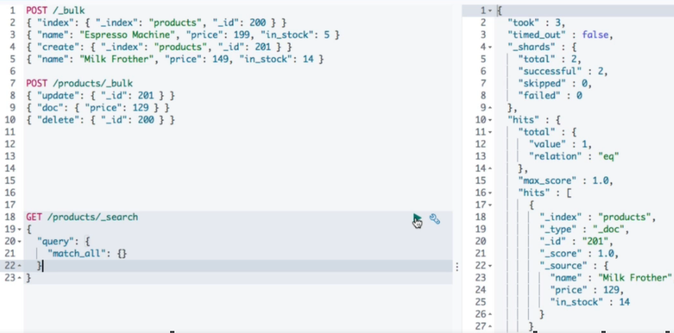

The _bulk URL can also have the index name like in the second example if all operations are related to the same index.  
  
if_primary_term and if_seq_no parameters can be used within the metadata to bring optimistic locking into effect.

## CURL with bulk JSON file

**curl -H 'Content-Type: application/x-ndjson' -X POST** [**http://localhost:9200/products/_bulk**](http://localhost:9200/products/_bulk) **--data-binary "@products-bulk.json"**

# Analyzers (_analyze API)

POST /_analyze

{

"text": "2 guys walk into a bar, but the third.... DUCKS! :-)",

"analyzer": "standard"

}

POST /_analyze

{

"text": "2 guys walk into a bar, but the third....DUCKS! :-)",

"char_filter": [],

"tokenizer": "standard",

"filter": ["lowercase"]

}

## Inverted Indices

Lucene data structure capabilities are used to perform searches to map a term to matching documents.  
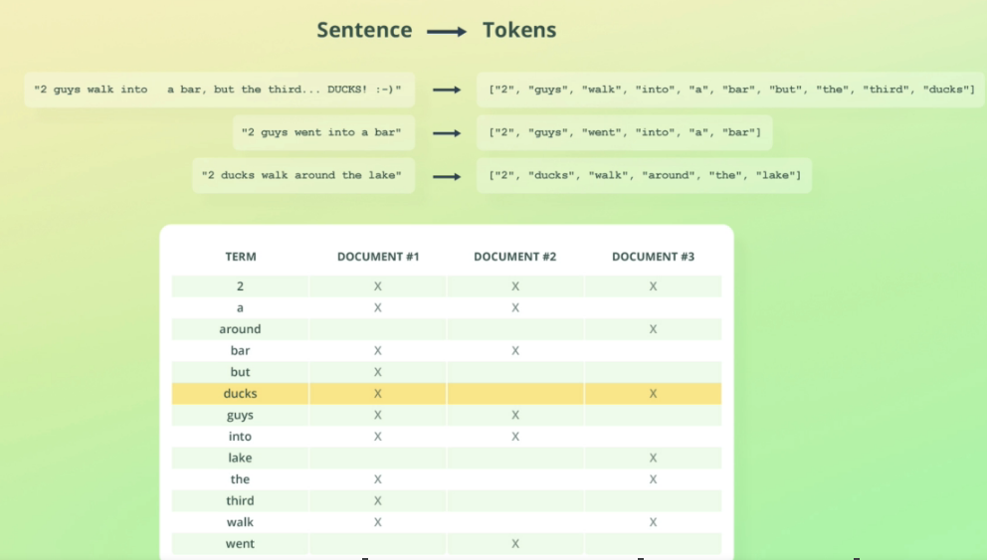

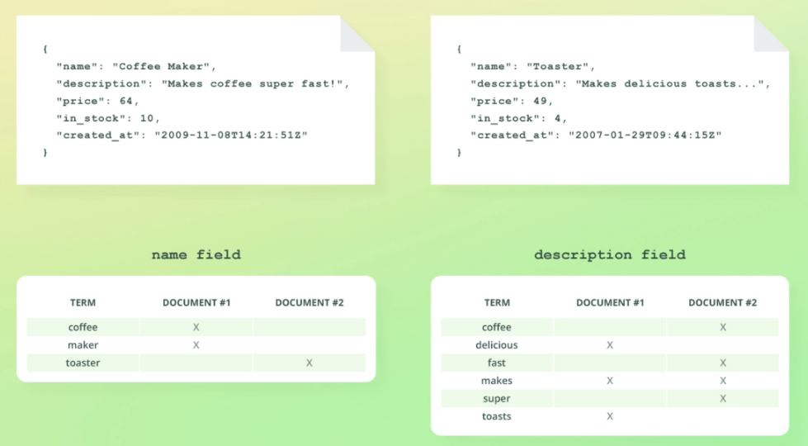



# Datatypes

[**https://www.elastic.co/guide/en/elasticsearch/reference/current/mapping-types.html**](https://www.elastic.co/guide/en/elasticsearch/reference/current/mapping-types.html)



IP – IP address

## Object

  
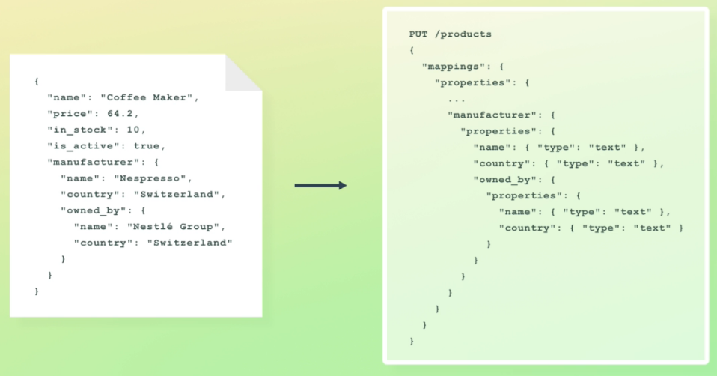

### Flattened

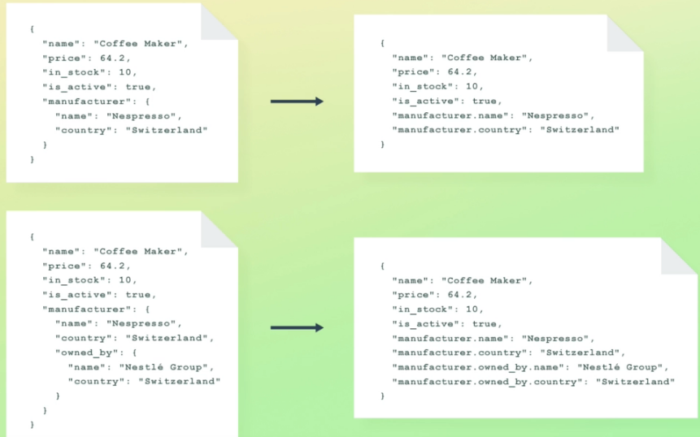

What about array then?

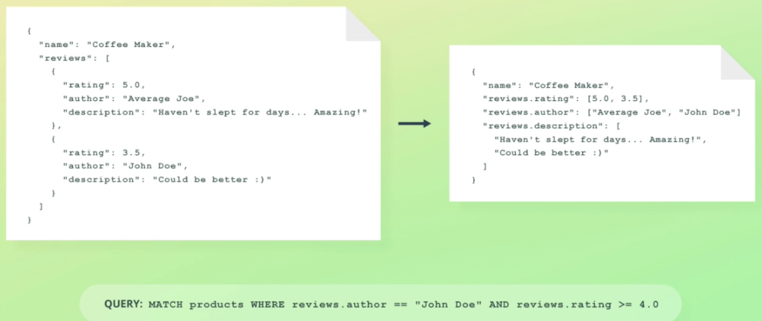

Ohh, it is maintaining arrays with all values together for each property.

But the query starts returning wrong data. We asked for > 4.0 rating from John Doe but it would return what he rated 3.5 also. This default behavior putting everything of a property into a array does not work (it is working like OR condition but not AND) if we want to maintain relation between John Doe and 3.5 strictly. Nested data type comes to our rescue.

## Nested

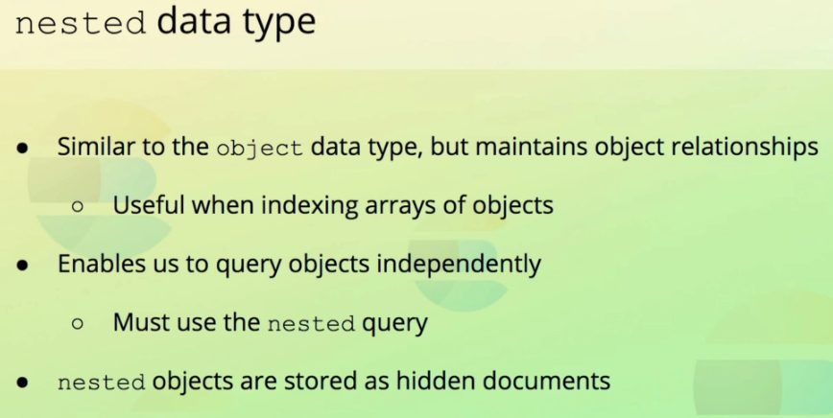



One document per product and one document for **each review under that product** is flattened and maintained.



## Keyword

for exact searching



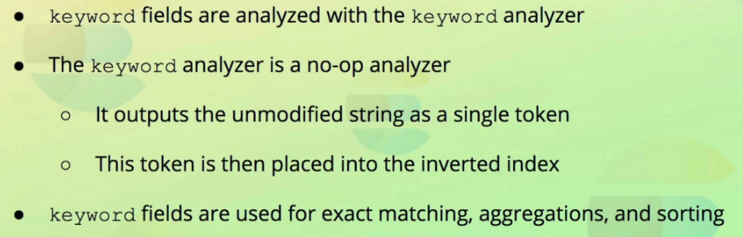

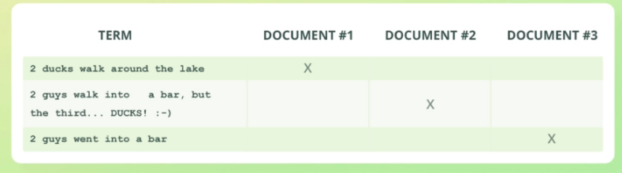  


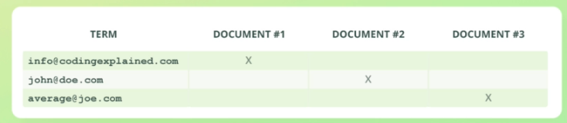



## Arrays



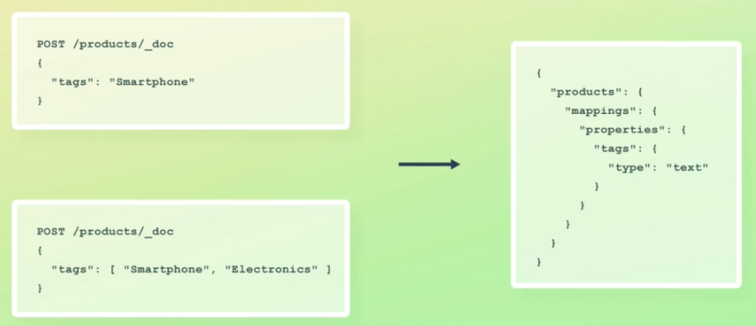

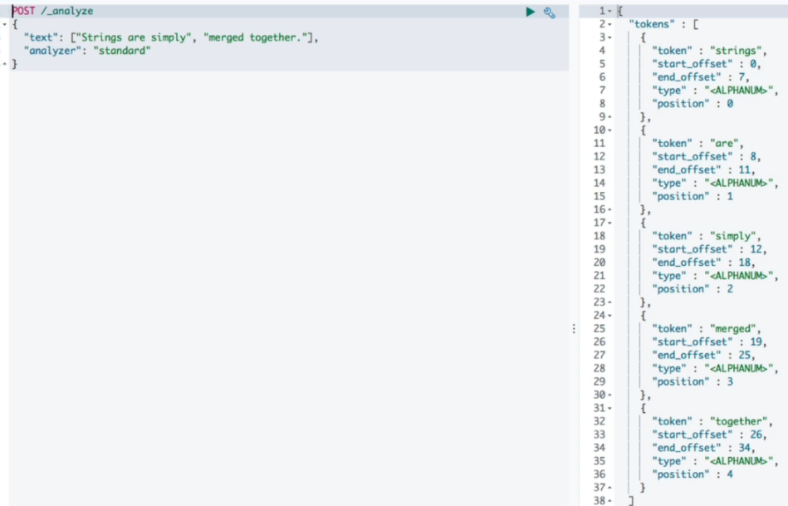

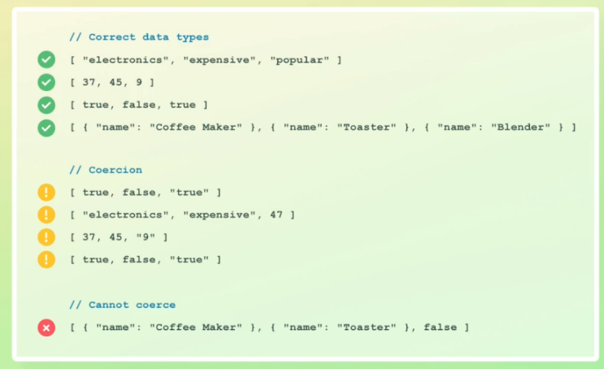

## Nested Arrays

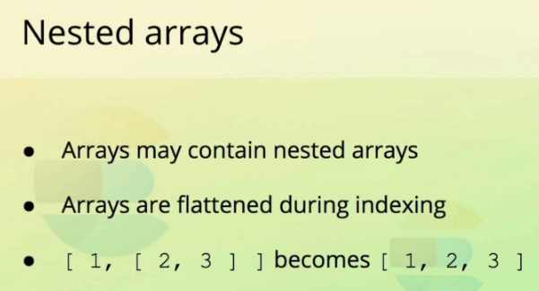



So far when indexing documents, we just added documents to the index without defining the mapping/datatypes of each field. Elasticsearch used to give a guess based on the data used and apply coersions (automatic data conversion based on first document data for a field) on subsequent documents when indexed.

# Explicit Mappings

Explicitly we are mentioning the datatype of each field so that elasticsearch is aware of the expectation when adding/indexing new documents. Coersions can still happen if not disabled at field or index level. So a number can be converted to a string if the field mapping is string. But surely an object in a new document will not be converted to a string if the field mapping is string.

## Create a new index Mapping

PUT /reviews

{

"mappings": {

"properties": {

"rating": { "type": "float" },

"content": { "type": "text" },

"product_id": { "type": "integer" },

"author": {

"properties": {

"first_name": { "type": "text" },

"last_name": { "type": "text" },

"email": { "type": "keyword" }

}

}

}

}

}

PUT /reviews/_doc/1

{

"rating": 5.0,

"content": "Outsyanding course! Bo really taught me a lot about Elasticsearch!",

"product_id": 123,

"boom": "random unmapped field",

"author": {

"first_name": "John",

"last_name": "Doe",

"email": "johndoe123@example.com"

}

}

## Retrieve Mapping

To know the datatype of fields in the index

GET /reviews/_mapping

GET /reviews/_mapping/field/content

GET /reviews/_mapping/field/author.email

## Easier dot notation while creating mapping

Easy to read the query

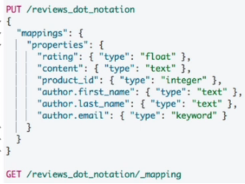

## Adding a field mapping to an existing index

PUT /reviews/_mapping

{

"properties": {

"created_at": {

"type": "date"

}

}

}

## Mapping date field



### Default behavior of date fields

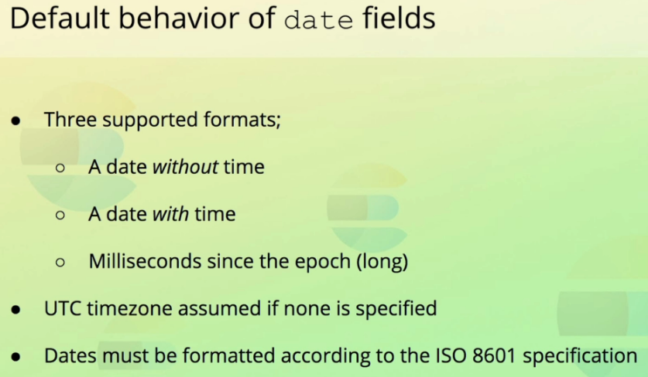

### How date fields are stored

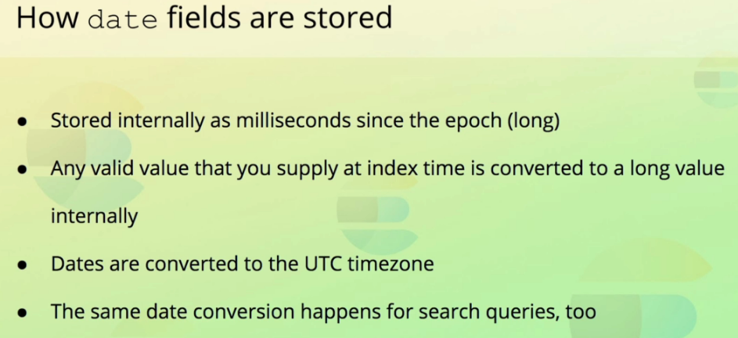

<https://www.elastic.co/guide/en/elasticsearch/reference/current/mapping-date-format.html>

Indexing documents with date field mentioned in different formats. Ultimately it is the milliseconds of UTC since epoch that is stored by elastic search

PUT /reviews/_doc/2

{

"rating": 4.5,

"content": "Not bad. Not bad at all!",

"product_id": 123,

"created_at": "2015-03-27",

"author": {

"first_name": "Average",

"last_name": "Joe",

"email": "avgjoe123@example.com"

}

}

PUT /reviews/_doc/3

{

"rating": 3.5,

"content": "Could be better",

"product_id": 123,

"created_at": "2015-04-15T13:07:41Z",

"author": {

"first_name": "Spencer",

"last_name": "Pearson",

"email": "spearson@example.com"

}

}

PUT /reviews/_doc/4

{

"rating": 5.0,

"content": "Incredible",

"product_id": 123,

"created_at": "2015-01-28T09:21:51+01:00",

"author": {

"first_name": "Adam",

"last_name": "Jones",

"email": "adam.jones@example.com"

}

}

PUT /reviews/_doc/5

{

"rating": 4.5,

"content": "Very useful",

"product_id": 123,

"created_at": 1436011284000,

"author": {

"first_name": "Taylor",

"last_name": "West",

"email": "twest.jones@example.com"

}

}

**Returns documents with created_at exactly as in when added but internally it is coerced into a UTL epoch milliseconds format.**

GET /reviews/_search

{

"query": {

"match_all": {}

}

}

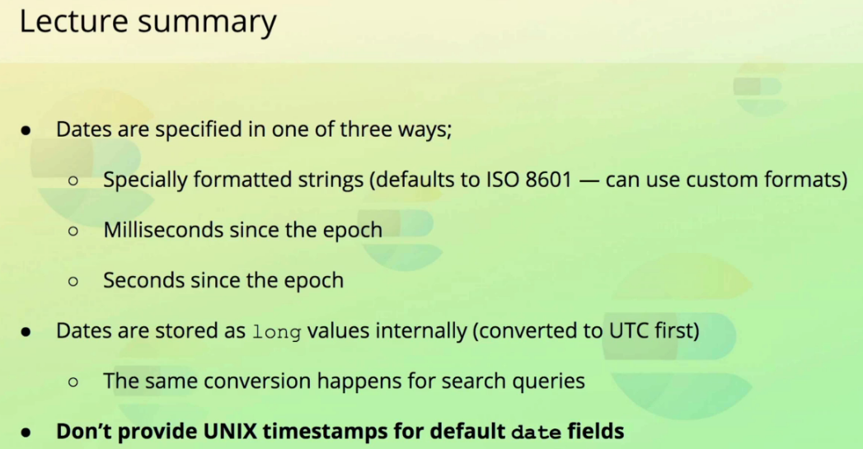

### Missing fields in the document

<https://www.elastic.co/guide/en/elasticsearch/reference/current/mapping-params.html>

Many field mapping settings in above link and some below….

### ‘format’ parameter in mapping a field

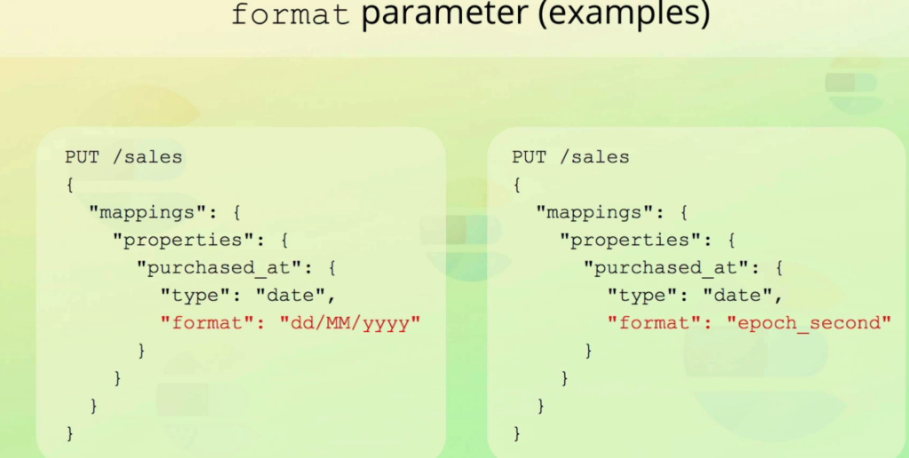

epoch_second is the unix timestamp which is in seconds but not milliseconds

## ‘properties’ parameter for mapping sub-object/nested field

## Enabling/Disabling auto ‘coerce’ of field values

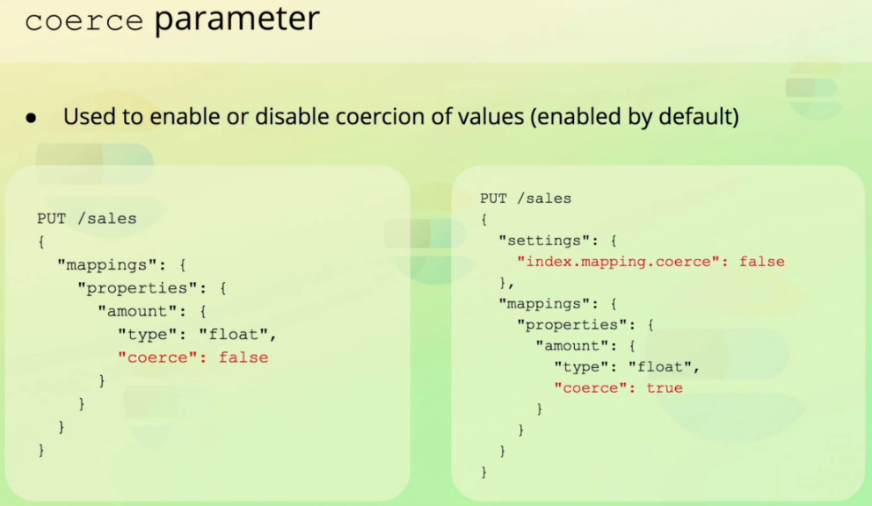

## Enabling/Disabling ‘doc_values’ for better sorting by field





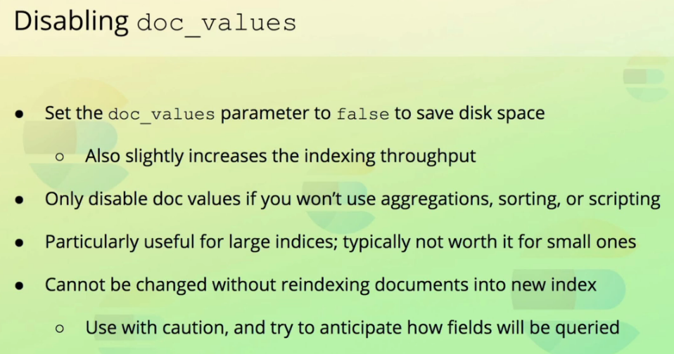

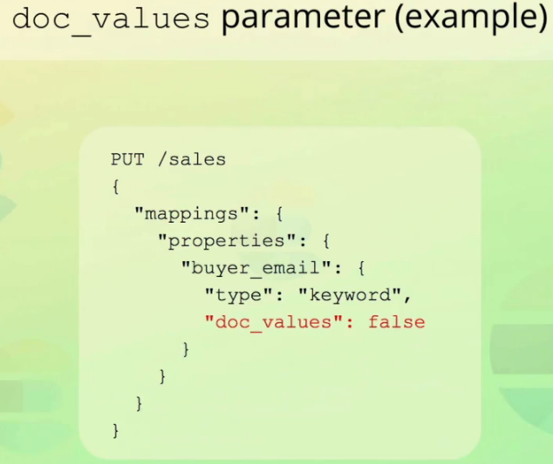

## Enabling/Disabling ‘norms’ parameter for better relance scoring in search result

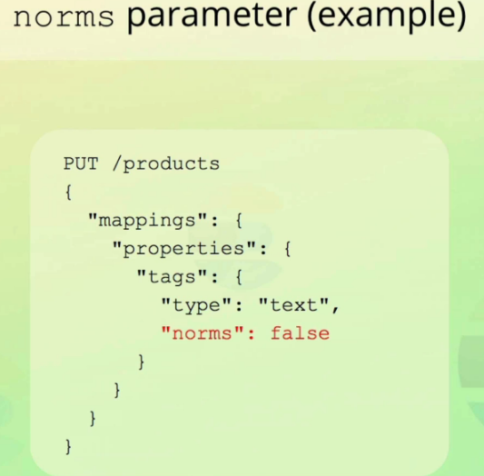

## Enabling/Disabling ‘index’ parameter for indexing a field

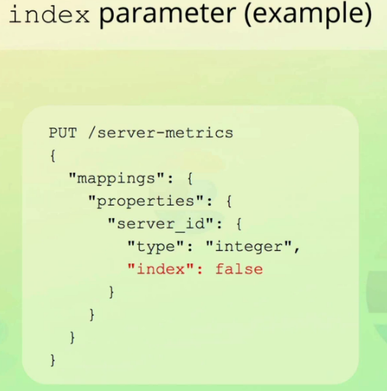

## Setting default value for NULL

So that it can be indexed. Otherwise, NULL values are not indexed and hence are not searchable.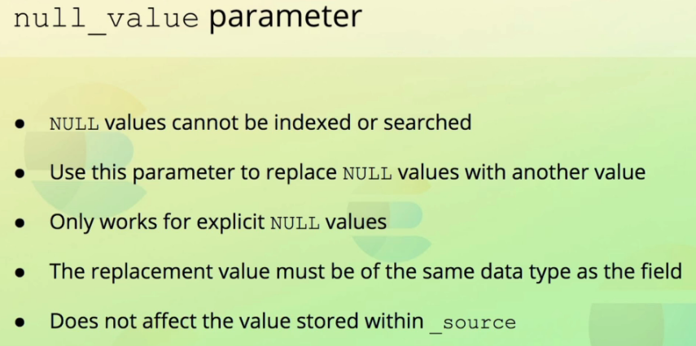

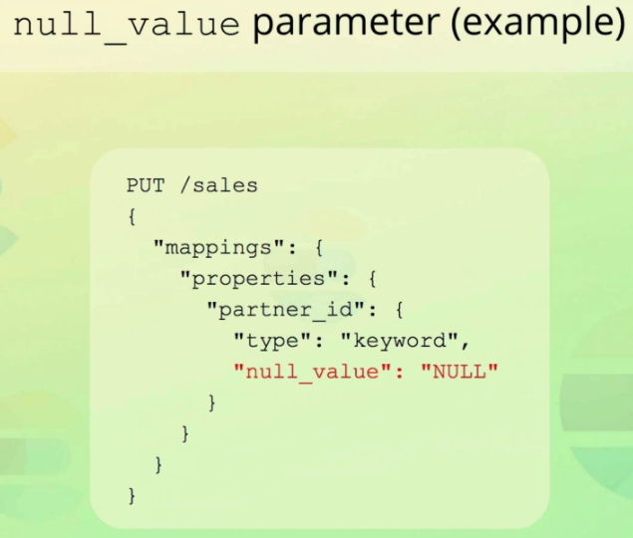

## Setting ‘copy_to’ parameter for grouping multiple fields into one value

Not stored under _source but is searchable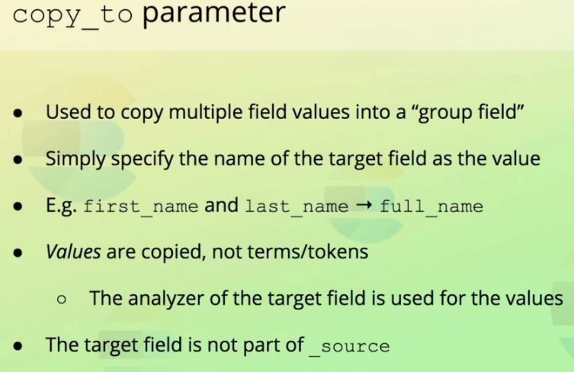

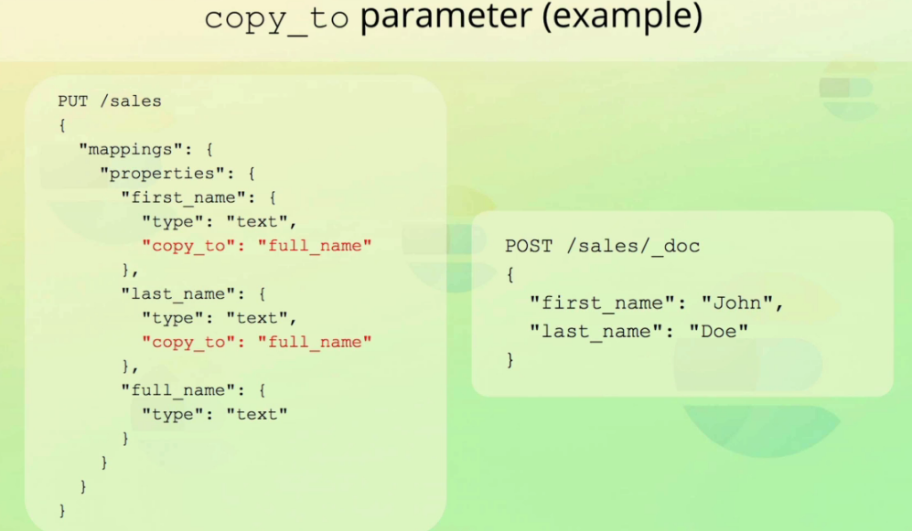

## Updating existing field mapping

This is not possible because of various limitations on how each field is indexed.  
long to keyword cannot be changed because long value are indexed using BKD trees but keyword is through Inverted indices. There can be data coercion issues too.

So whole document having millions of records is to be looked at. See following product_id field being remapped from integer to keyword not allowed.  
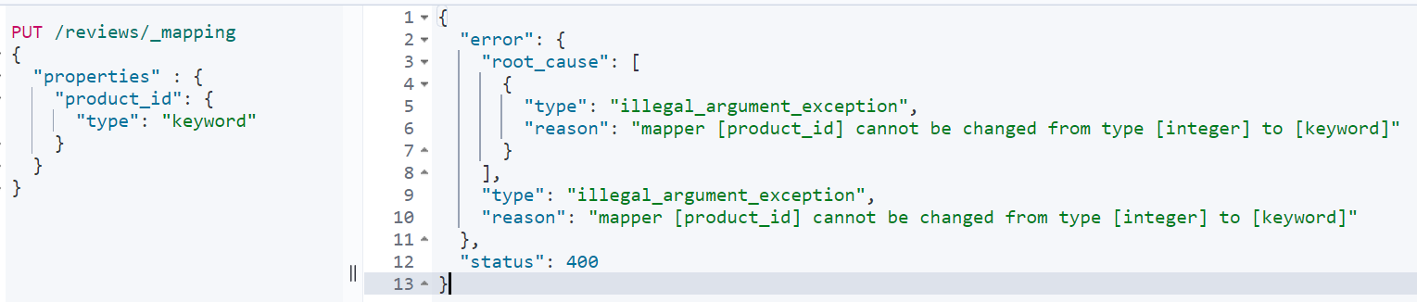

Some properties (like ‘ignore_above’) around the existing field mapping can be modified but not the field type itself. In the following example email value of an author if longer than 256 will not be indexed.

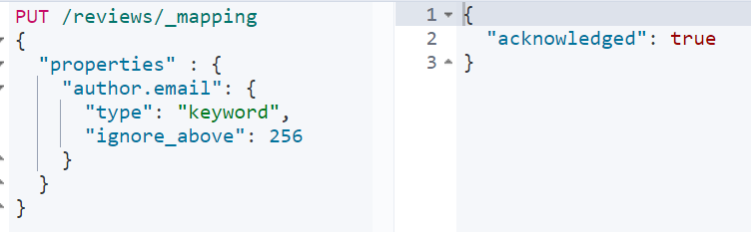

## Reindexing documents with _reindex API

When a field is to be remapped to another datatype, the only solution is to

* *GET /reviews/_mappings* to get current mappings  
  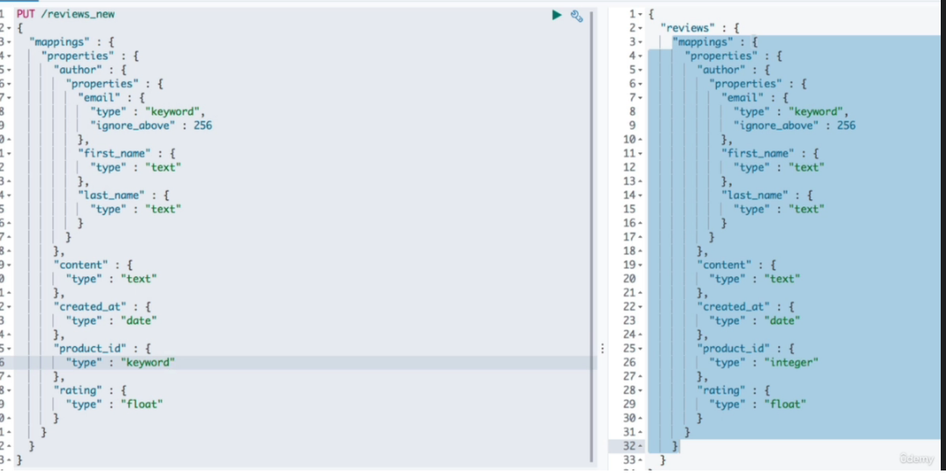
* Copy current mappings from above result
* Create a new index (reviews_new) with modified mappings of required fields
* Use reindex API to copy/reindex from old index to new index.



### Reindex to copy from existing index

POST /_reindex  
{

"source": {

"index": "reviews"

},

"dest": {

"index": "reviews_new"

}  
}

GET /reviews_new/_search

{

"query": {

"match_all": {}

}

}

### Observation – Existing documents value type not changed

Everything looks good but the _source has product_id still as an integer value in reviews_new. The internal indexing would have used keyword but the product_id _source is confusing. It would use coercion to convert from integer to keyword while indexing. To, fix the data under _source, we will have to add script while using _reindex API.

POST /reviews_new/_delete_by_query

{

"query": {

"match_all": {}

}

}

### Reindex with script explicit data value conversion

POST /_reindex

{

"source": {

"index": "reviews"

},

"dest": {

"index": "reviews_new"

},

"script": {

"source": """

if (ctx._source.product_id != null) {

ctx._source.product_id = ctx._source.product_id.toString();

}

"""

}

}

### Reindex only documents that match a query

### Reindex only positive reviews greater than 4.0

### Reindex to include only selected fields

Only fields mentioned under _source array would be used during reindex.  
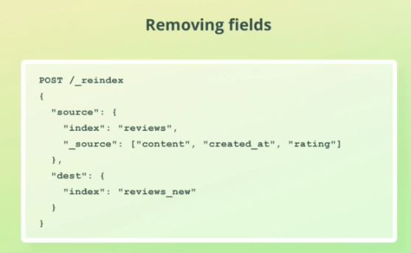

### Reindex with a field name changed in the destination index

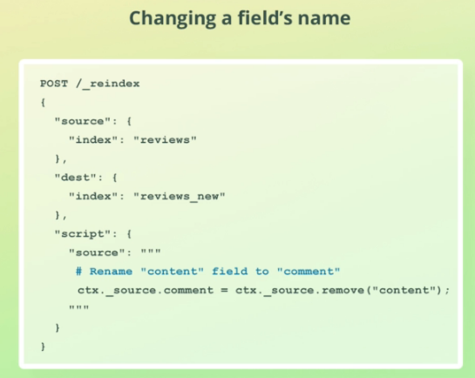

### During reindex, Ignoring documents using script

This is similar to the query parameter used earlier. Query parameter is performant than this script method setting ctx.op

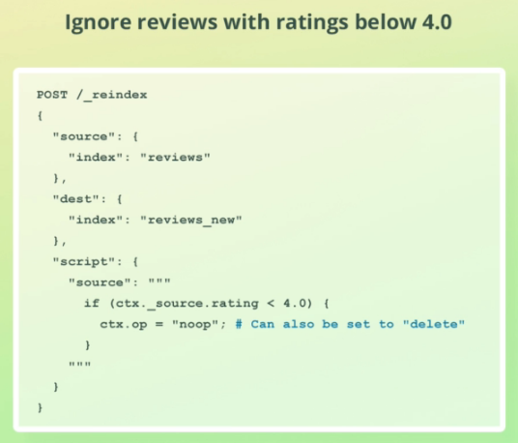

### Advanced

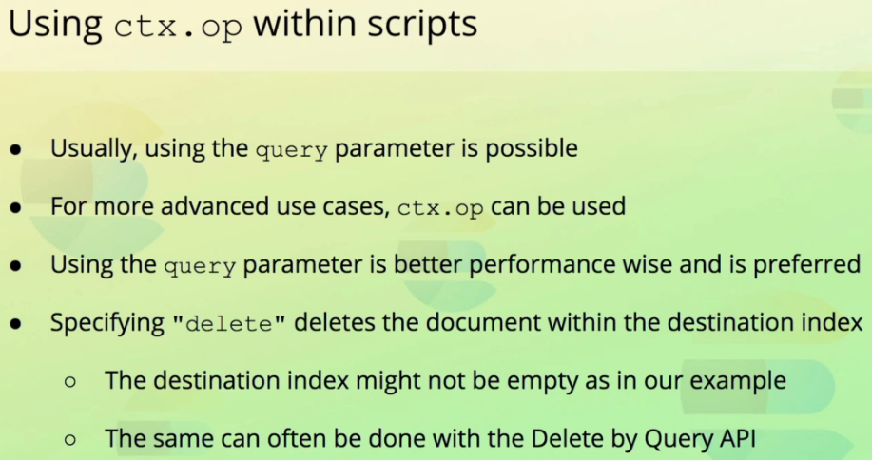

<https://www.elastic.co/guide/en/elasticsearch/reference/current/docs-reindex.html>

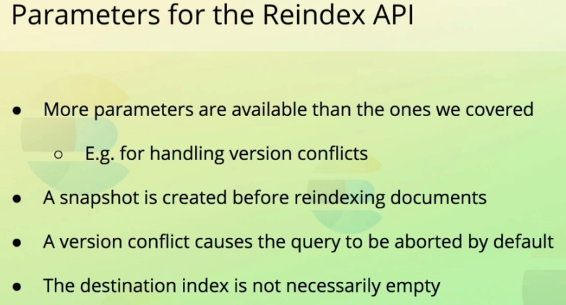

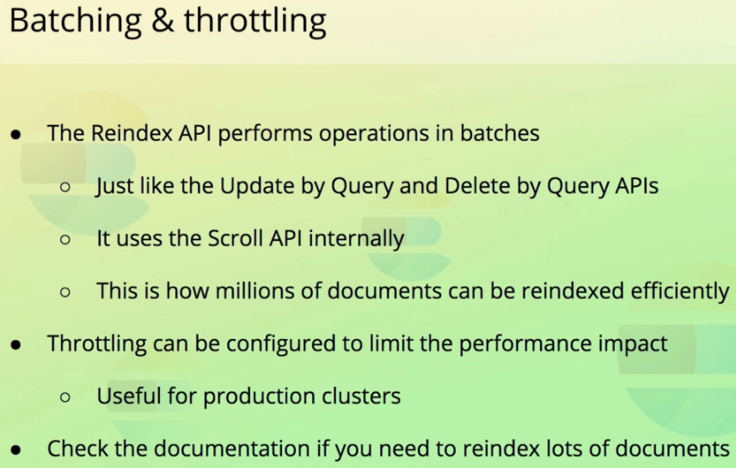

## Defining field aliases

Renaming a field is not a good option when millions of documents exist. An alternate is to provide an alias to the field.

PUT /reviews/_mapping

{

"properties": {

"comment": {

"type": "alias",

"path": "content"

}

}

}

In the above example, ‘comment’ is the alias name given to a field ‘content’. Following is where we can used ‘comment’ & ‘content’ interchangeably to search for documents.

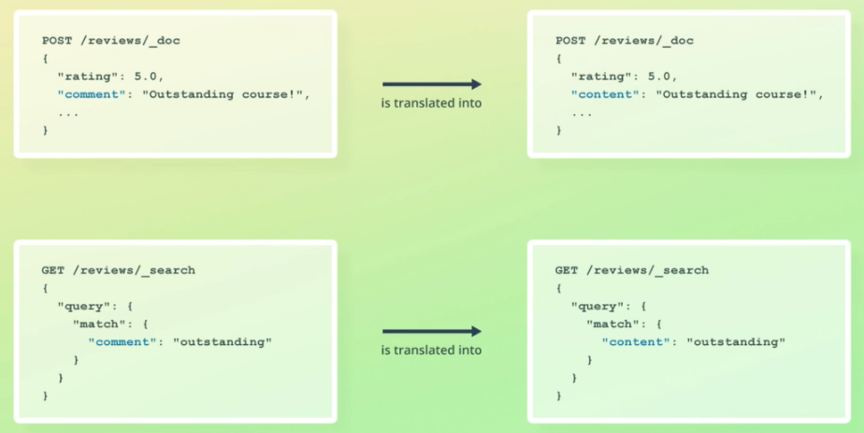

GET /reviews/_search

{

"query" : {

"match": {

"**content**": "outsyanding"

}

}

}

GET /reviews/_search

{

"query" : {

"match": {

"**comment**": "outsyanding"

}

}

}

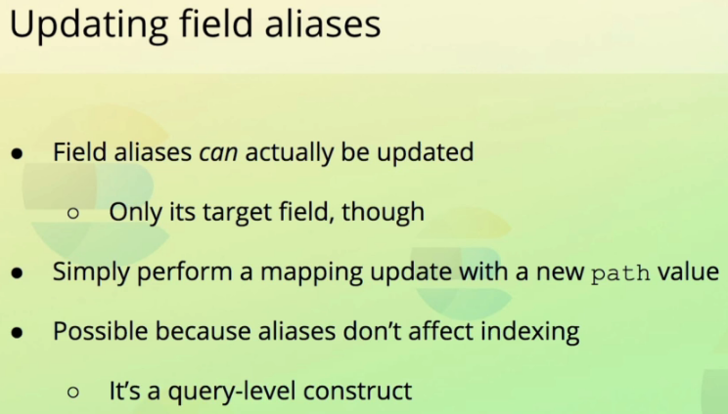

Note: Alias at an index level is also possible. Refer to elasticsearch documentation.